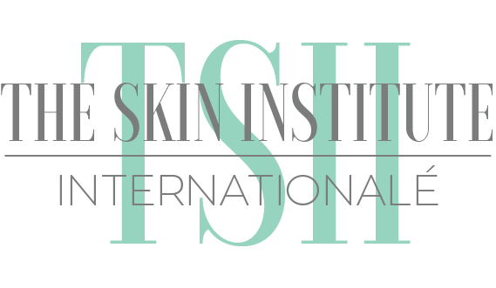 Specialty Course Enrollment Form
Full Name: | Date: |  | DOB:
Cell Phone: |  | Email:
Full Permanent Address: | Circle your field of practice:  Esthetician Massage Therapist  Barber Nail Tech  Cosmetologist None of The Above
Enrolling for: (Check one)  _____ Microblading Certification ____ Facial Machines Class  _____ Ad. Waxing Certification ____ Makeup Certification  _____ Lash Extension Certification ____ Volume Lash Ex.  _____ Dermaplaning/Peels/Co2 ____ Other:____________  _____ Microneedling Certification  *Skip Down to Class Selected | Beauty Operator #: TSII Student/Graduate:  Yes | No  # of Years licensed:
Date of Specialty Course Enrolling for:

For future reference, interested in:
Place of Work (Current Employer/ Beauty Shop): | Form of Payment: Visa MasterCard Check  Cashier’s Check Cash Received:___________
Microblading Course
Three Day Class (Extensive theory, manual, and demos provided. Two models required.) $2,995.00+Tax
Includes Full Extensive Kit for 50 clients
Lash Extension Course- Must be licensed
Two Day Class (Extensive theory, manual, kit, and demos provided. Two models required.)
BELLALASH Classic Starter Kit $1,095.00+Tax BELLALASH Classic “PRO” Kit $1,495.00+Tax
BELLALASH Classic Small Kit $1,295.00+Tax (most popular) BELLALASH Volume Kit/Course $1,295.00+Tax
(must already be certified in Classic Lashes Volume 2 day Class)

Waxing Class- Must be licensed
Two Day Waxing Class (Extensive theory, manual, and demos provided. Two-Four models required.)
$695.00+Tax Medium Kit (One Pot, 3 cans of wax and all other supplies)
$895.00+Tax Large Kit (Two wax pot holder, 6 cans of wax and all other supplies)
Machines Class- Must be licensed
Two Day Machines Class, ALL machines are taught. (Extensive theory, manual, and demos provided. Two models required.)
$1,295.00+Tax Microdermabrasion Machine Kit $1,195.00+Tax UltraSound Machine Kit
$1,195.00+Tax Microcurrent Machine Kit $1,195.00+Tax LED Machine Kit
+ Microderm Machine $275 +Ultrasound Machine $175 +Microcurrent Machine $175 +LED Machine $175
Dermaplaning/ Peels w/ Cryotherapy- Must be licensed
Two Day Class (Extensive theory, manual, and demos provided. Two models required.)
$1,195.00+Tax (Extensive kit to do 15+ Procedure)
Lash Lifting Class- Must be licensed
One Day Class (Extensive theory, manual, and demo provided. One models required.)
$599.00+Tax (Elleebana Lash Lift kit)
Microneedling- Must be licensed
Two Day Class (Extensive theory, manual, and demo provided. Two models required.)
$1,695.00+Tax (Stelo Pen/Products)
Makeup Certification
Two Day Makeup Artistry Certification (Extensive Theory, manual, demos, and models needed.)
$699.00+Tax (Variety of Brand Makeup Kit and Supplies)
Paying in Full: $ ______ Paying Partial to hold my seat in class ($500 for all courses- NON REFUNDABLE)
Down Payment Received: $ ___________ Date: _____/______/_______ Remaining: $ ____________
Full Payment Received: $_____________ Date: _____/______/_______
TSII Representative: ______________________________________ Enroller Signature:__________________________________________

